Appendix A

The VirCan.01 model (Virtual Cannabis)
1. A concept of L-System modeling, software, and modeling technique

The VirCan.01 model has been developed using the L-studio (University of Calgary) software [1]. This software package for Windows contains the CPFG (Plant and Fractal Generator with Continuous Parameters) and provides additional interactive graphic tools that facilitate model specification and manipulation. CPFG is a plant simulation program based on the formalism of Lindenmayer systems (L-systems) and its distinctive feature is the flexible modeling language that allows the user to specify the architecture of various modular organisms including plants and ecosystems.
The central concept of L-systems is a concept of rewriting [3]. Generally, rewriting is a technique for defining complex objects by successively replacing parts of a simple initial object using a set of rewriting rules or productions. Conspicuous geometric features of plants such as bilateral symmetry of leaves, the rotational symmetry of flowers, their self-similarity being the result of developmental processes, made the L-systems formalism a convenient and useful technique for modeling plant architecture. Development of this technique, especially the introduction of open L-systems, allowing communication with a model of the environment and/or with the mechanistic models of plants, created opportunities for virtual modeling of real plants and studying a variety of aspects of their architecture dynamically.
The model can be descriptive or mechanistic and in the latter case, the user can study the impact of physiological and environmental processes on plant growth and development. The results of simulation are visualized as schematized or realistic images of plants (virtual plants). Numerical results can be accumulated and saved in user-defined format files as needed for further analysis. To support functional-structural modeling, L-studio contains programs that simulate environmental processes, for example, light distribution in the canopy - a necessary feature for our goal of developing a model useful for Cannabis detection.
L-Studio is software that simplifies use of the L-system-based modeling and simulation program, CPFG, under Windows operating systems. A model consists of a set of related files placed in a common directory. This directory and its files are called an L-studio object or project. L-studio facilitates project management (for example, a project can be open or saved as a whole), and provides tools needed when working with various files used by CPFG.

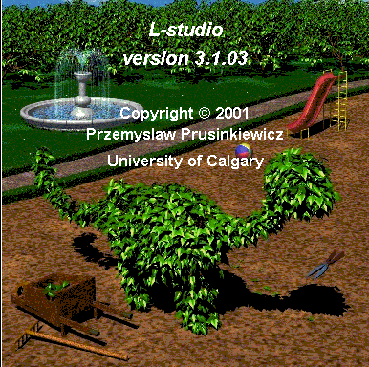
Fig. 1. L-studio
The L-Studio contains the following folders:
- L-studio.bin
- oofs
- enviro
- extras
- lpfg
L-studio.bin contains all binaries necessary to use L-studio.
- cpfg.exe - CPFG program
- cpp.exe - C preprocessor
- fwa.dl, fwogl.dll - dynamic-link libraries used by L-studio
- LStudio.exe - LStudio executable
It also contains these folders:
- enviro.bin - contains sample environmental programs
- Help - contains help files in the HTML format.
“oofs” contains sample L-studio objects (projects).
“enviro” contains compiled communication library and communication library header file.

The graphical interface of L-studio is organized according to the Microsoft MDI format. L-studio is represented on the screen as the main window, and an open project is represented as a single document (project) window within the main window. In general, there may be any number of projects open at the same time and manipulated from the Window menu: Tile horizontally, Tile vertically, Cascade, Close all. The user can also switch between the projects by using the Window menu. After a project has been opened, its contents (all files from the project directory) are copied to a temporary directory. All changes made to any component are stored in the temporary location. There are several tabs at the top of project window. They are used to switch between project sections (L-system, View etc.)

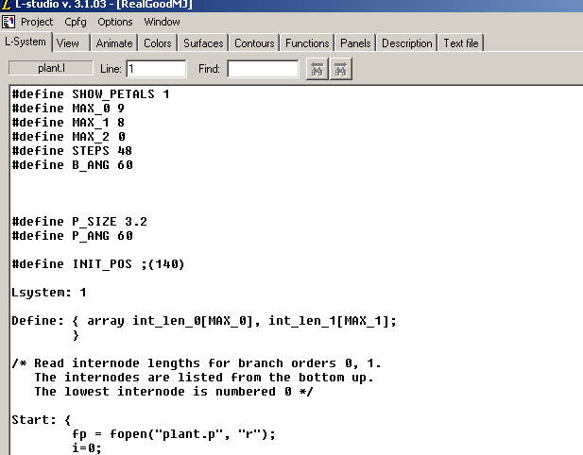
Fig. 2. Main window of the L-studio.
A single project is a set of files that is contained in a single directory. Commonly-used files are listed below:
- L-system file (*.l)
- View file (*.v)
- Animation file (*.a)
- Color map file (*.map)
- Materials file (*.mat)
- One or more files describing surfaces (*.s)
- One or more files describing contours (*.con)
- One or more files describing functions (*.func)
- Files describing panels (*.pnl)
- Other files. These may be, for example:
  - text files (e.g., project description, communication specification file *.e),
  - image files (textures),
  - executable programs (environmental programs)
L-studio provides specialized editors for the first eight file types. In addition, any text file can be edited using the general Text file editor tab.
The L-system section contains a program of a virtual model. A typical program looks like the example shown in Fig. 2. Variable names are defined as in C programming language. Three types of programming statements written usually according to C grammar can be included in an L-system program: assignments, conditional, and global programming statements. The values of parameters of a plant model often depend on the order of apex, or branch. Therefore, it is possible to define arrays that we used in our programs presented here. A number of useful functions can be included in L-system expressions, mathematical functions, opening and closing files, inputs and outputs. Several specific features are also provided to facilitate plant modeling. It is often convenient to apply concepts of structural programming to L-system models and to divide bigger structures into independent parts. This allows the modeler to first describe the development of some parts of the plant, and then combine the pieces together in a complete model. Thus, the design of a model is more efficient and it is possible to re-use productions simulating the growth of certain plant organs in other models. We also used the sub-systems feature in our models. For these purposes, it is also advantageous to use an L-system homomorphism and decomposition that allows the modeler to change details of the appearance without modifying the underlying logic of the model.
In L-system modeling, there is the basic concept of a turtle that is an object with certain qualities (specified by the program) that moves around a computer screen and draws our virtual plants. The state of the turtle is defined by its Cartesian coordinates to determinine the turtle position, and an angle called the heading that is interpreted as the direction in which the turtle is facing. Given the step size and the angle increment, the turtle can respond to specific commands of the L-system language that control the turtle movements. There are commands for changing position and drawing, for rotations, and for changing turtle parameters such as color or line thickness. There are two specific commands for modeling structures with branches. Command “[“ pushes the current state of the turtle (with all its parameters) onto a pushdown stack, and “]” pops a state from the stack and makes it the current state of the turtle. There are also commands to create polygons, circles and spheres, bicubic surfaces, and cylinders. Special commands define tropism and twist depending on the elasticity parameters. An important part of the L-system language are the query and communication commands that allow the development of open L-systems.
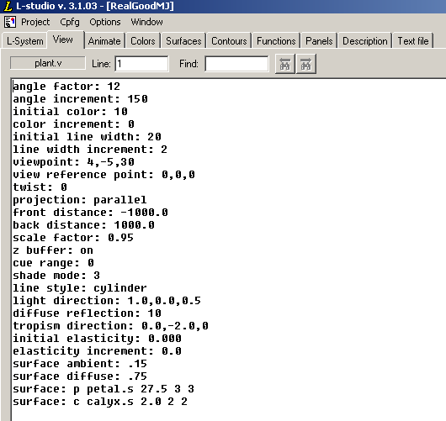
Fig. 3. View file

A view file contains drawing, viewing, and rendering parameters as well as the names of surface specification files for any surfaces to be included in the image. Here constants setting (1) the turtle’s parameters (line and surfaces colors and width, for example); (2) the view, e.g. the view point where an observer is located, a distance from the object, type of projection (parallel or perspective), scaling; and (3) general drawing parameters, (for example, surfaces can be colored from one or both sides, filled in a simple or interpolated mode, or approximated by splines or other standard mathematical functions, etc.). File fonts can be specified in the view file if there is some text in the view. Depth cueing and shading modes can be specified. Lines in the virtual plants can be presented as simple lines of a certain width, as cylinders, or as “pipes” with polygons in cross-section.

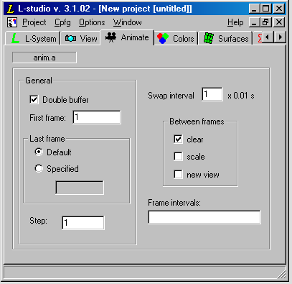
Fig. 4. Animate section

The Animate section opens the animation file in a form-based editor. This text file contains animation parameters.
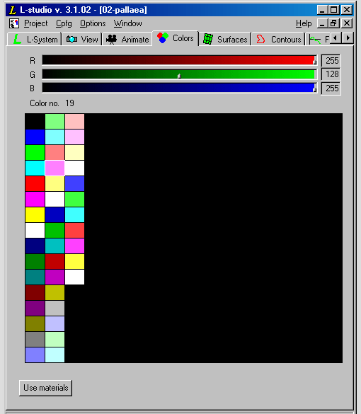
Fig. 5. Color map editor
The color map editor acts on a 256-entry color palette. Values for RGB components are set using three sliders located above the palette. The user selects a palette entry (one square whose color number will be shown at top left) by clicking the mouse. The user can also select a range of entries by clicking on an entry and then clicking on another entry with the Shift button pressed. When a range is selected and the user clicks the right mouse button, the following commands are available through a context menu:
- smooth: interpolates linearly for values of RGB components of selected cells from the first selected entry to the last selected one;
- inverse: inverses (negates) colors in the selected entries;
- reverse: reverses the order of entries in the selected range.
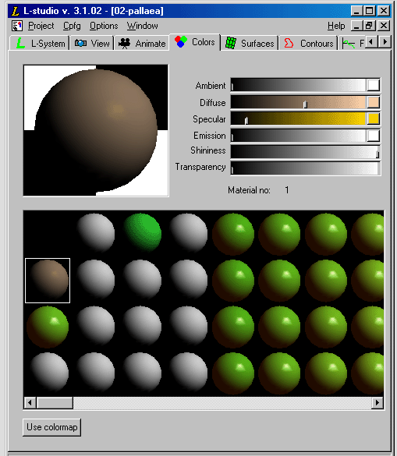
Fig. 6. Material editor
The material editor acts on a single material selected from the material gallery. The number of the selected material is shown at mid-right and a preview of the selected material is shown in the left top corner of the editor. There are six sliders to the right of the preview window. The top four are used to set the ambient, diffuse, and specular reflection coefficients of the material, and the intensity of light emitted by it. This feature is very important to us as by choosing a material with a certain color and spectral reflectance properties, we can simulate the reflectance properties of marijuana leaves. We have collected the corresponding experimental data and will apply this to the virtual modeling of Cannabis. To manipulate colors, click the button on the right side of the respective slider. This brings up a color selection dialog box.
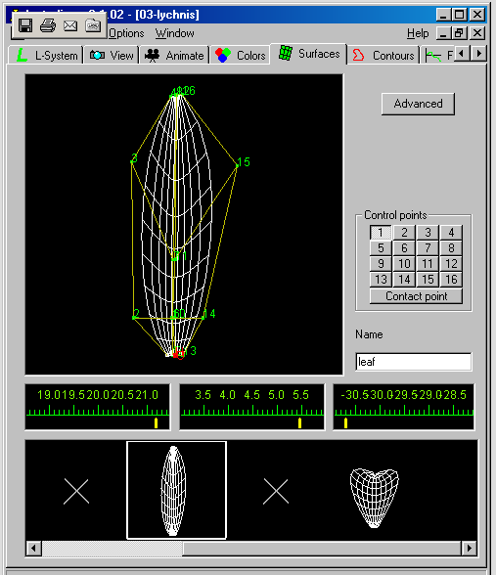
Fig. 7. Surfaces section
The editor in the surfaces section is based on the same paradigm as the material editor: it consists of an editing window, a preview window for the selected surface, and a gallery of surfaces. The number of surfaces in the gallery is not limited. The selected surface is shown in the preview window in the top left corner of the editor. The preview window can be in one of two modes: (1) rotate and (2) lock XY.
In the rotate mode the user can perform following actions:
- Rotate the view around the coordinate system's origin by clicking with the left mouse button and dragging the mouse
- Zoom in or out by clicking the middle mouse button or clicking the left mouse button while pressing the Ctrl key and then dragging the mouse up or down
- Pan the view by clicking the left mouse button while pressing the Shift key and dragging the mouse
In the lock XY mode the surface cannot be rotated but it is seen in parallel projection on the XY plane. The surface can also be edited with the mouse. The surface can be edited in both modes. To this end, select a control point using a button labeled 1-16. Three sliders located below the preview window make it possible to manipulate the X, Y and Z coordinates of the selected point.
In addition to the control points, the surface editor makes it possible to manipulate the contact point associated with every surface. The surface can be displayed as a wire frame or as a shaded surface.

A new (default) surface can be added to the gallery by selecting New from the gallery's context menu. A surface can be also removed from the gallery by selecting Delete from the gallery's context menu. One can also select an existing surface from the gallery, edit it, and add the modified surface to the gallery as a new one. Every surface has a name.
The contour section provides another editor based on the view-edit-gallery paradigm (like the material and surface editors). The contour is defined as a B-spline curve that can be changed by manipulating control points. The points can be moved, added or removed. The user can also change the multiplicity (strength of attraction) of each point, between three levels. Select the edit mode using the buttons on top-right. The modes are: move points, add points, delete points.
- In the move points mode click-and-drag the point with the left mouse button
- In the add mode click where you want the new point to be added
- In the delete mode click on the point you want to delete
- To change the multiplicity of a point double-click on the point in the move points mode. White color indicates points multiplicity of one, green indicates the multiplicity of two, red indicates the multiplicity of three. 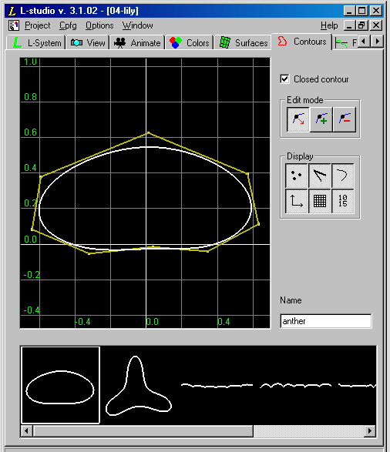
Fig. 8. Contours
It takes at least four points to create a contour. A point of multiplicity value of two counts as two points. A point of multiplicity value three counts as three points. Contours can be closed or opened. To change the type of the contour, check or uncheck the Closed contour check box.
One can toggle the display of the control points, the control polygon, the edited curve, the coordinate system axes, the grid and the labels on the grid using buttons grouped in the Display section. Operations involving the gallery: retrieving, adding and deleting contours, as well as applying changes work in the same way as the surface editor.
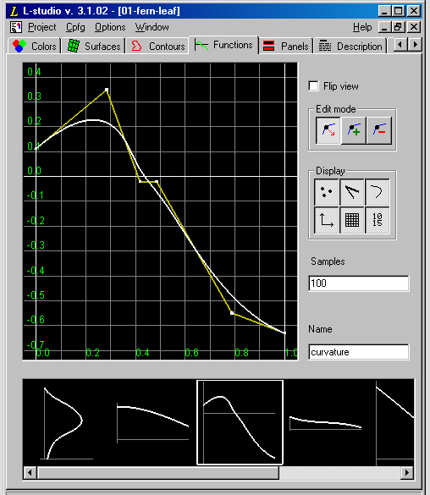
Fig. 9. Functions section

The functions section provides an editor that is very similar to the contour editor. The objects being edited are also cubic spline contours with some additional constraints. The constraints are:
- That the X-coordinate of the first point is equal to 0 (zero)
- That the X-coordinate of the last point is equal to 1
- For any two consecutive points p_{i} and p_{i+1} on the curve X_{pi} <= X_{pi+1}.
These conditions assure that the curve can be interpreted as a function of X.
For information on manipulating the control points and the view see the instructions for the Contour editor. Elements found in the function editor not present in the contour editor: Flip view. The functions can be displayed in two ways. Traditionally the function f(x)=y the domain (X) is associated with the horizontal axis, while the range (Y) is associated with the vertical axis. Sometimes it might be convenient to assume that X is the vertical axis and Y is the horizontal axis. To do this you can check the Flip view check box. Flip view is a property of a function; therefore it is possible to have only some of the functions flipped. This property is saved together with a function only if the gallery of functions is bound into a function set.
Panels are used to control parameters during experiments.
Description section is a text editor working in exactly same way as L-system and View editor. File name for this editor is fixed. It is always description.txt. The text file section opens a simple editor that can be used to edit any text file.
After the model is written, parameters set, surfaces, contours, and functions are specified, one can run the model by clicking Go! under cpfg option. The left mouse button is used to rotate the model and moving the mouse will cause the image to rotate in the direction of mouse movement. Moving mouse up and down while holding down the middle mouse button rescales the image in the cpfg window. A menu, activated using the right mouse button< is provided for interaction with cpfg. The menu controls re-reading of input files, regeneration of the image, output in a variety of formats, and the switch to and from animation mode. These items control the animation process. The option Begin Recording gives access to a sub-menu allowing the user to initiate recording in a selected file format. After picking Run from the animate menu, all subsequent frames are recorded, until Stop Recording is selected.

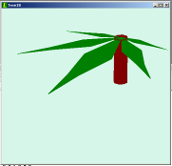
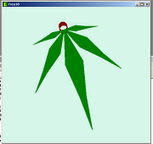

Fig. 10. A simplified L-system model of marijuana leaf
in cpfg window in the initial position (left) and after
rotating an image in this window. A petal was made thick
intentionally for demonstration how lines can be represented
as hollow cylinders

The cpfg menu allows the user to save output files in a number of different formats including RGB, RAS, TGA, RLA, BMP, Rayshade, etc.
Open L-systems use the communication modules to send and receive environmental information. Special parameters x₁, …, x_{m} act as an interface between the plant and environment. They can be set by the plant model and transferred to the environment or set by the environment and transferred to the plant model. To accommodate the exchange of information between the plant and its environment each derivation step (a step of rewriting or a unit period of growth) is followed by the environmental step. Upon encountering a communication symbol, the plant process creates and sends a message to the environment including all or part of the following information: (1) the address of the communication module; (2) values of the parameters; (3) the state of the turtle (coordinates of the position and orientation vector, as well as some other attributes, such as the current line width); (4) the type and parameters of the module following the communication module in the string of commands. It is also possible to include a graphical representation of the module.
The environment processes the received information and returns the results to the plant model using messages in the following format: (1) the address of the target communication module; (2) values of parameters carrying the output from the environment. The plant process uses the received information to set parameter values in the communication module. Fig. 11
shows the organization of the open environmental model linking the L-system model, plant
growth model, and the environmental data.

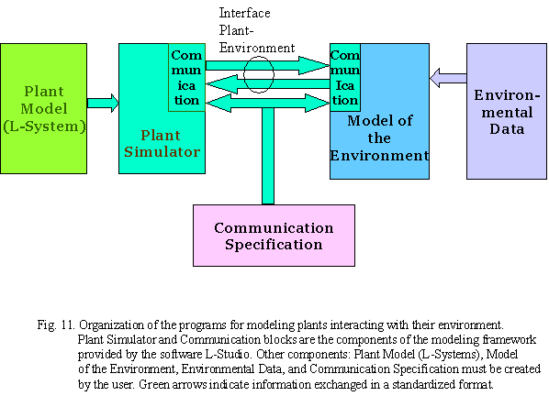

It is often useful to visualize not only the plant model but also the environment, to better understand the interaction between them. There are two ways of doing this: (1) as a background image(s) and (2) as a set of primitives forming a background scene that is displayed with the generated plant(s). The primitives are read from a text file containing special commands. When the environment is changing over time, it is necessary to update the image or the background scene every time the environment changes. Consequently, the background file is periodically updated by the environmental process and read by the plant simulator after each simulation step, before the visualization.
An environmental process communicating with the plant simulator operates as a subordinate, i.e. the communication is controlled by the plant simulator (the “boss”). There are a number of special programs useful for our purposes. For example, the environmental program chiba determines the amount of direct light reaching leaves. Another environmental program, Monte-Carlo, determines the amount of light reaching objects in a scene. This program recognizes two objects, triangle or a polygon (leaves’ surfaces are formed by these shapes with an appropriate accuracy). The amount of light reaching all or selected objects is computed using the path-tracing algorithm, based on Monte Carlo techniques. Generally, the light coming from the light sources (in the form of rays) is traced through the scene. Every time the ray reaches an object, it is determined whether the light is absorbed, reflected, or transmitted through the object, based on the surface parameters associated with the object. We can determine these parameters with the data on reflectance (part of the experimental work), then select a proper material to make our leaves from.
The software also provides a program computesky that can be used to generate a file with a density functions capturing the light intensities at different parts of the sky. The function is then directly used for generating initial rays in the Monte Carlo program so that more rays are traced from the parts of the sky with higher light intensity. The density file corresponds to an average light intensity of the sky at a given location on earth for a given period of time. Specifically, the program computesky takes the longitude and latitude of the place of the simulated experiment as an input, the first and the last date of simulation, and the percentage of overcast days during the time period.
The program terrain determines the altitude and optionally the normal and a water content at a given point. Temperature can be read directly from the weather data written in a special format.
All the program parts can be used as a part of a specific model depending on the purpose of modeling.
We can specify the leaves with various materials. Parameters of surface materials are defined in a specification file processed by the environment at the beginning of the simulation. Each material is defined by 4 parameters:
- Reflectance – controls the percentage of the incoming radiant power that is reflected from the surface. A value between 0 (black body) and 1 (a perfect reflector) can be used.
- Reflectance scattering exponent – specifies the roughness of a surface. Value of 0 represents a perfectly diffuse surface, for which the radiant power of the reflected ray does not depend on its direction – the higher the value the smoother the surface.
- Transmittance – controls the percentage of the radiant power being transmitted through the surface.
- Transmittance scattering exponent – similarly as the reflectance exponent, it specifies the degree of scattering of the transmitted light. For the value of 0, the light is scattered equally in all directions, while for higher values, more rays are concentrated around the “ideal” direction of the transmitted ray.
There are also recent extensions to the graphical interpretation of L-systems based on the turtle geometry, resulting in a higher degree of realism of visualized plant models. For example, an additional set of parameters, elasticities, specify the susceptibility of the direction adjustments due to tropisms. Circles and spheres have been added to the list of interpreted primitives (like line). It is often desirable to create smooth curvatures, especially when modeling plants that contain many curved segments. One approach is to model a curved branch segment with several short straight segments approximating the curvature. The advantage of this method is the possibility of the internal control of the curvature by L-system productions. On the other hand, this approach makes L-system productions rather complicated and elongates the generated string.
In another approach, curved branches are modeled as generalized cylinders. A set of control points defines the axis of a generalized cylinder as a parametric curve consisting of a sequence of cubic curve segments. The cross-section of a branch segment, for example a disc, is then swept along the cylinder axis creating a three-dimensional object. It is possible to use an arbitrary contour defined as a closed three-dimensional parametric curve consisting of several B-spline segments. Generalized cylinders are visualized using cylindrical mesh strips with a certain number of polygons around the mesh. It may be also useful to use open contours to define the cross-sections of a long thin leaf blade, for example. By default, generalized cylinders are drawn in such a way that their twist is minimized to obtain smooth connections. To be able to create twisted segments (that is sometimes necessary, i.e. in a case of soybean plant, see an example below), it is possible to switch off the minimization of twist and even to set a special parameter for the twist. Using homomorphism, it is possible to create smooth branching structures consisting of the generalized cylinders. However, it is slower to draw generalized cylinders than straight-line segments, so the choice depends on the particular purpose of the model. We used cylinders, and with contemporary computer speed, found it quite acceptable to draw them for our plants.
A standard computer graphics method for defining surfaces makes use of parametric bicubic patches. This technique is well suited for interactive design of arbitrary surface shapes. The control points that define an individual patch can be modified using a graphical interface (see above a description of the L-Studio, Surfaces section)., and several patches can be combined to create a more complex surface. The resulting surface definition can then be stored in a file for use during turtle interpretation. Predefined surfaces are incorporated into a plant model by extended the L-system alphabet. When the turtle encounters a symbol representing a surface preceded by a tilde (~), the corresponding surface is drawn. It is very easy to use this method but predefined surfaces do not grow. If a developmental sequence is required, surfaces representing individual stages of surface growth must be separately defined and incorporated into the model.
An alternative approach is to allow the turtle to create polygons directly but it complicates the program and makes it quite difficult to debug. We used the first approach with predefined surfaces using scaling parameters for growing leaves (in case of soybean) or distribution of those parameters according to the leaf size measurements (in case of marijuana). However, in future we are going to use the second, more flexible approach, after our L-system modeling experience is good enough.

- Our Virtual Plants: Three L-system models developed for plants grown in control climate chambers and in field conditions

Three different L-system models (virtual plants) were developed on the basis of the experimental data and the data analysis described in Section 3:
  - VirCan 0.1 (chamber) (Virtual Cannabis in climate control chambers);
  - VirCan 0.1 (field) (Virtual Cannabis in the field);
  - VirSoy 0.1 (Virtual Soybean in climate control chambers).
They are all open L-systems models and will be developed as the later versions (a development is underway) into the environmental models according to the scheme presented in Fig. 11. Currently, they communicate with the environment exchanging (reading and writing) the information with the files containing the environmental information as well as the experimental arrays needed to build a proper morphology for the modeled plants. The VirSoy 0.1 model was developed first because we had the necessary data for soybeans, and the experiments with marijuana were still in progress. We used the soybean data to learn the L-system modeling technique and to explore the possibilities provided by various ways of modeling plant development for branching structures. This exercise allowed us to choose the optimal way of modeling marijuana accounting for our purpose of modeling. After training with soybeans, it was much easier to develop the models for Cannabis. The results for soybeans also allowed us to publish our results in leading journals for peer-review without drawing attention to the emphasis on Cannabis.
The VirCan 0.1 (chamber) and VirCan 0.1 (field) models were developed with the experimental data from the climate-controlled chambers and from the field experiments, respectively. There is a lot in common in development of plants in both kinds of conditions, but there are also some significant differences. Geometry of the branching structure is the same but quantitatively, the difference was quite substantial, branches of the filed frown plants were longer and had more nodes in the lower part of the plant, and they were relatively much shorter or even disappeared at the upper part with the main apex was still growing fast and forming additional nodes and leaves. Accounting for these differences, we decided to develop two different L-system models. Since the L-systems programs logic for these two models is similar, and the differences are modeled mostly in L-system parameters, there is always a possibility to make a single open model which would simulate the plant grows for the artificial or for the field conditions depending on another additional control parameter.
All three models are parametric L-systems. This is the best way to model the growing, branching structures. But the way of parameterization for the models for soybean and for marijuana is different. The VirSoy 0.1 model has two parameters in its productions. One parameter controls the branching and the second one is time. This allowed us to make a virtual plant grow gradually. Both models for marijuana are also two-parametric in their productions. But in this case both parameters control the branching pattern. We need two parameters for the virtual marijuana because of the branching pattern specific for this species. Soybean morphology (for the cultivars we were working with, especially, but for many other soybean cultivars, there was always the same pattern of branching, as we observed in the literature) is quite conservative. It grows 2-3 side (2nd order) branches, but the main stem grows and increases a number of nodes till the end of its life cycle that always occurs at a certain moment and the growth stops completely, except flowers and fruits. Marijuana develops the side branches continuously, till the end of the period of observation in chambers, and only in the field conditions the side apices appeared but did not develop into long branches within the period of observations. Besides, marijuana sometimes develops 3rd order branches. There are only few of them but in our opinion, this way of development has to be accounted for in the model of the virtual Cannabis. This is one of the reasons why both production parameters in the marijuana L-systems models were given to branching processes, for an expense of the special parameter for time. The modeling technique allows introduction of the 3rd parameter, for time specifically, but this is the next step in our models development. It has its own challenges that can be solved and we are working on it.
Another reason that determined our way of L-system modeling of marijuana at this stage of the models development is that to simulate marijuana morphology quantitatively, we had to explicitly use experimental data in simulations. Unlike the soybean model, we used arrays for modeling the node growth, and the internode lengths were read directly from the files containing the experimental values. This made us to use two productions’ parameters from the start, and the third one, time-related parameter, will be introduced in our further versions of the model(s).

The VirSoy 0.1 model. Fig. 12 shows photographs (1-6) of Essex cultivar plants at the moments of 6 measurements for day/night temperatures 32/27ºC, a visual L-model of these plants (1a-6a), and plant maps (schematically) at the same times (1b-6b). The maps were used for recording the measurements and as a first step of data generalization for L-modeling.
There was no qualitative significant morphological difference between the Essex and Moon Cake (not shown) cultivars. The number of branches and leaves differed within 10% for all treatments. The only morphological difference was observed in the first lowest branches. Two branches were growing at the second node (after unifoliolate leaves fell) on the Essex plants, and for the Moon Cake, branching began from the third node. However, the quantitative differences between the two cultivars were remarkable. Moon Cake plants were about 1.5 times higher than Essex plants at the moment of the last measurement, when the flowering began at two higher temperatures because of the longer internodes.
The effect of temperature was significant from the moment of emergence. Plants of both cultivars at higher temperature were developing faster, always being one vegetative stage ahead at higher than at lower temperature. Plant height was about 2 fold for the intermediate (26/21ºC) and 3 fold higher at the highest (32/27ºC) than at the lowest (21/15ºC) temperature, affecting accordingly the internodes length. However, before flowering plants at two higher temperatures

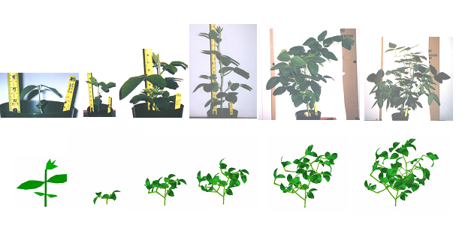
1
2
3
4
5
6
1a
2a
3a

4a
5a
6a

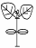

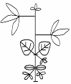
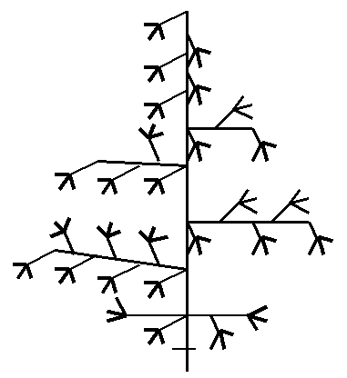
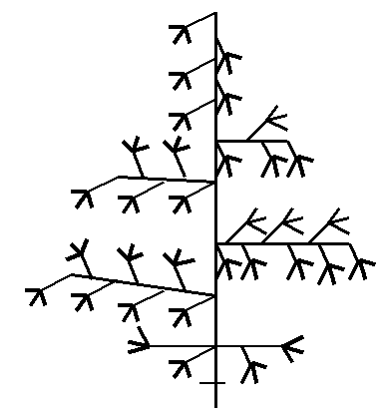

1b 2b 3b 4b 5b 6b
Fig. 12. Photographs (1-6), L-models (1a-6a), and plant maps (1b-6b) for soybean, cultivar Essex, grown at 32/27ºC (day/night) till flowering, one week after emergence (1, 1a, and 1b), and then with time interval of one week. Image 1a is shown 30-fold bigger for clarity.

temperatures were of about the same height, and only in the coldest chamber they were very short. Leaf sizes for the same cultivar were different at early (V1-V4) stages of development for different temperatures, and their distributions became quite close at the beginning of the reproductive stages.
Figure 12 shows that L-models can closely simulate growth and development of these two soybean cultivars both qualitatively and quantitatively, even accounting for the sophisticated main and secondary stem shapes. Simulations were successfully run for all treatments. The movie for soybean growth recorded from the virtual model can be viewed in QuickTime, Windows Media Player, and in Power Point Presentation software. All necessary files for viewing the animated models are in the Appendix disc.

The VirCan 0.1 (chamber) and VirCan 0.1 (field) models are shown in Fig. 13, and Fig. 14, respectively. The photographs of the real plants growing in chambers and in the field are shown in the next section where the experimental data and its analysis are described. We don’t have a series of photographs from emergence till the end of experiment because the plants were growing from cuttings (Fig. 15), then propagated in a greenhouse (Fig.16), and the experiments done in climate-controlled chambers (Fig. 17) and in the field (Fig. 18) began from a stage of growth when the plants have already formed their morphological structure.
Although L-Studio, as mentioned in the previous section, allows us to model very fine details of the plant organs, at this stage of the model development, we simulate only the form of leaves. Our aim is to use the model for detection, therefore, the leaf properties are important, and leaf shape is of special interest. Considering the link of the L-systems model to the plant growth model, stems’ photosynthesis is not taken into account. So we modeled stems and branches as simple cylinders with approximately circled cross-section, approximated in this particular case with hexagons. Leaves were modeled as predefined surfaces for blades. Special parameters control the size of blade. Five blades (easy to make them 7 or any other number) are arranged in a typical marijuana leaf. Several parameters control plant size and number of branches. Model allows for the 3rd order branches. Internode sizes are read from the file containing the experimental internode lengths. These values are read into arrays, one for the main stem, and another for the branches. Internode lengths are assumed the same for all secondary branches but it is easy to make them dependent on the particular branch. The assumption was accepted for the first version after analysis of the experimental data. This version operates with color map option. Leaves color changes depending on stage of development and on illumination. The next step will be a switch to the materials mode with a proper reflectance values adjusted according to the experimental data that are collected. Temperature effect is accounted for with two parameters in the current version of the model. This will be also further developed in a process of the environmental model construction.

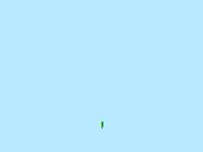
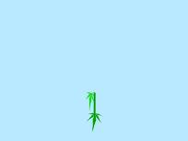
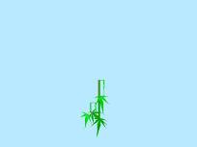
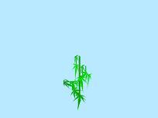
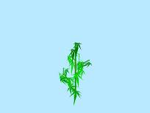
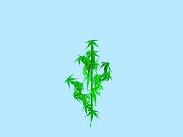
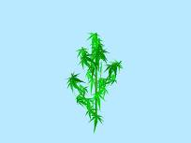

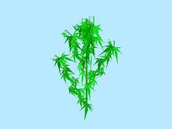
1
2
3
4
5
6
7
8
9

Fig. 13. Several consecutive frames from the animated model
of the VirCan 0.1 (chamber) model of the marijuana
plants growing in the climate-controlled chambers.
This simulation was made for the temperature 30/26ºC
treatment.


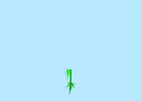

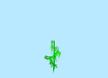
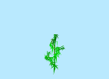
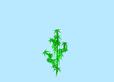



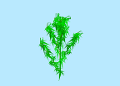
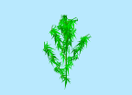








1
2
3
4
5
6
7
8
9
10
11
12
13
14
15
16
17
18
19

Fig. 14. Several consecutive frames from the animated model
of the VirCan 0.1 (field) model of the marijuana
plants growing in the field conditions.

Comparing Fig. 13 and Fig. 14 one can see that they grow differently, growth of the second order branches follows the corresponding pattern described above.

3. Experimental Data and Analysis

Design of the experiment and the list of measurements for experiments with marijuana are described in the previous reports. We will give here only a short description of the chamber experiment with soybean plants that was not described in our previous reports and that was an experimental basis for the model VirSoy 1.0.
Two varieties of soybean, Essex (a conventional grain type) and Moon Cake (a tall growing vegetable type) were growing in three controlled climate chambers at a photoperiod 14 hours, light intensity 390 μmol m⁻² s⁻¹, and temperatures 32/27, 26/21, and 20/15ºC (day/night). There were three replicates for each of the two cultivars. Temperature and photoperiod are known to be the leading environmental variables determining the rate of progress towards flowering for soybeans. The main effect of photoperiod is on floral induction. Since the major accent of this study was on the soybean vegetative development, temperature was the only environmental factor. Internodes, secondary stems, and petioles length and diameters, number of leaves, and leaves length and width were measured weekly and mapped as it is shown in Fig. 12, stages of development were determined. The data were statistically analyzed and some reliable dependencies were obtained, mostly for leaves sizes that allowed us to reduce an amount of measurements for the two last series when plants were already big and had many leaves.

Data for marijuana were collected during spring of 2003 in chambers and summer of 2003 in the filed. Fig. 15 shows the beginning of the experiment when cuttings were made and planted into containers filled with a special medium for normal growth of the cuttings into healthy plants. When plants were ready, they were transferred into pots and kept for a week in greenhouses to ensure a normal growth and development. There were twice as many plants in pots than it was needed for the experiments because some plants grew too slowly and/or demonstrated signs of diseases. As a result, we had a sufficient number of plants for experiments in chambers and in the field and even some plants were left in the greenhouse for use in future experiments.
Every two weeks the measurements were made according to the previously developed program. The results were organized in the database (currently quite primitive, but we plan to develop a user-friendly data base. A structure of the database and corresponding software have been developed and found).

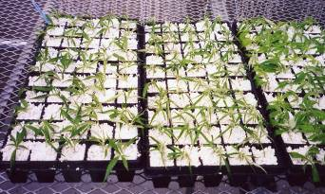

Fig. 15. Shows the beginning of the experiment. Cuttings planted in a special medium
are growing in a greenhouse.

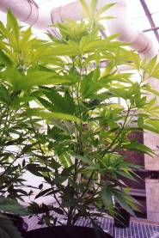
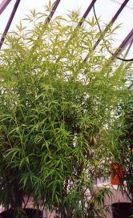
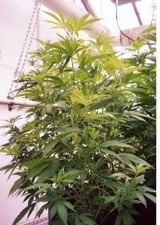

Fig. 16. Marijuana plants growing in greenhouses. The left plant is prepared for the experiment in the chambers, while the two other plants are sources of cuttings.

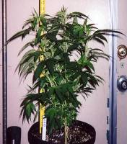
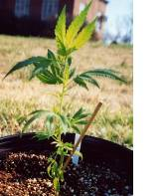
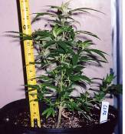

Fig. 17. Marijuana plants from the chambers at different stages
before the next series of measurements.

The climate controlled chamber experiment was conducted in three chambers with temperatures 24, 28, and 33ºC with two varieties of marijuana in three replicates. All the measurements that have been described in the previous report have been taken with a frequency of about 2 per week. In the field, the same measurements were taken several times. During the experiments, the data analysis was performed and that allowed us to decrease an amount of measurements. Marijuana’s growth is quite a regular process, as we observed in our experiments, and some characteristics strongly correlate with each other and this allowed us to exclude some measurements from the agenda in the subsequent series of measurements. Qualitatively, the plants in the field and in the chambers grew very similar, but the quantitative characteristics were very different. The correlation observed for the chamber growing plants, generally were established for the field grown marijuana.
At this stage of modeling, the major characteristics we needed were the plant height, number of nodes, internode lengths (for both primary and secondary stems), and the length of the branches. These measurements were analyzed first. ANOVA analysis showed that all these characteristics depend on both plant variety and temperature.
Plant Height. Figs. 18 and 19 present an increase of plant height with days from emergence. For all treatments and both marijuana varieties, this dependence has the same shape and could be formalized by the same function with different coefficients. Plant height grows
linearly till about 70 days from emergence, then its increase slows down. The best fit for the
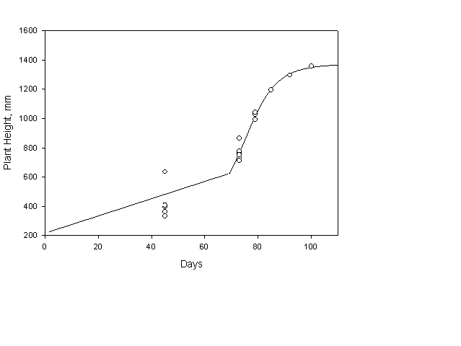
Fig. 18. Dependence of plant height on time for plant variety 1.

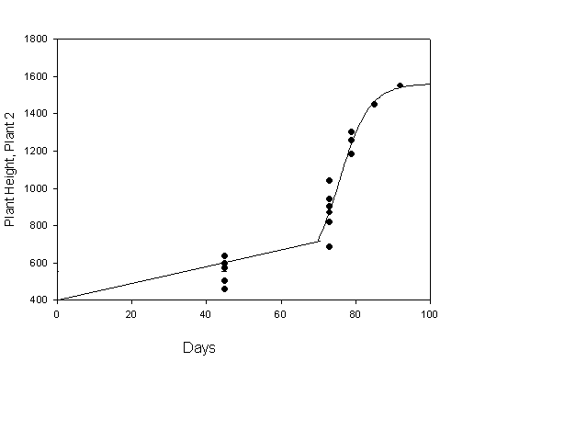
Fig. 18. Dependence of plant height on time for plant variety 2.

second stage was obtained with a sigmoid curve with 4 parameters:
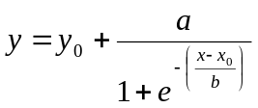
where y is a plant height, mm, x is time, days, and y₀, x₀, a, and b are parameters calculated with the experimental data. All parameters depend on the plant variety and on the temperature. This dependence allows us to model the growth of plant in an open L-system model, setting the shape of the function by the formula above and reading the parameters values from the environmental block.
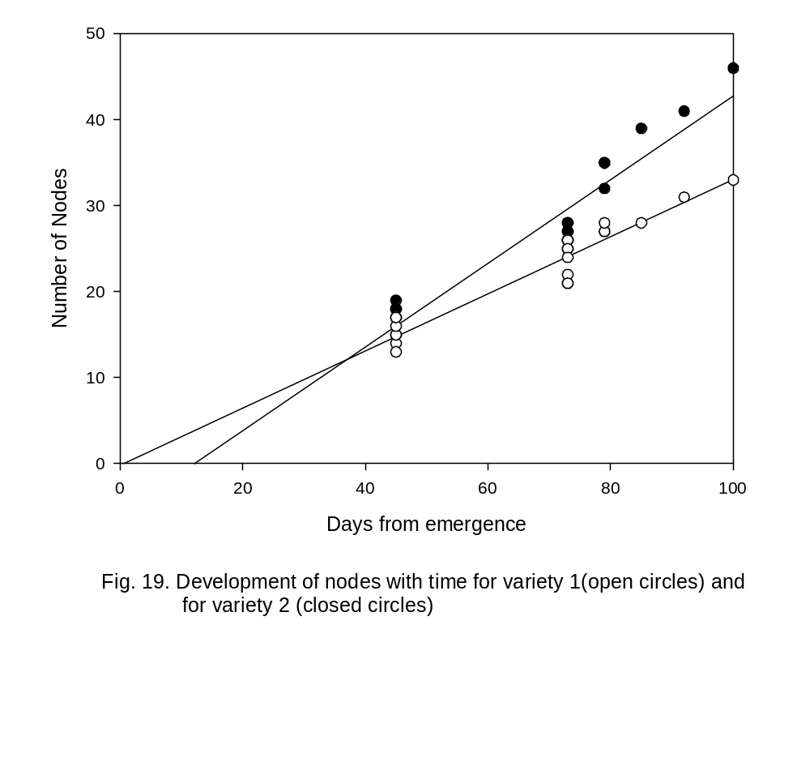
Fig. 19 presents the appearance of new nodes with time of growth. This is a linear function with a coefficient of correlation over 0.8 for all treatments. The parameters of the dependence also depend on both plant variety and temperature. In the warmest chamber this
function consists of two different linear dependencies switching at day 30.
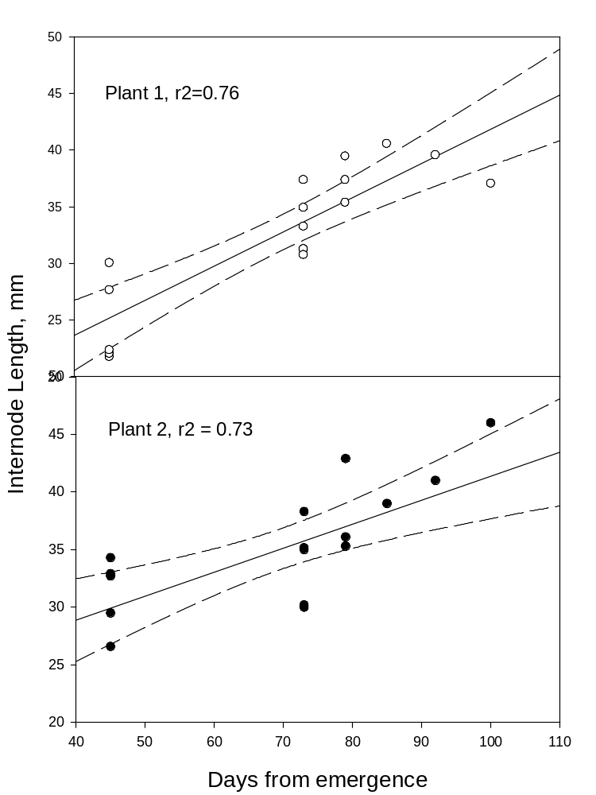
Fig. 20. Internode length growth with time.
Internode length can be calculated from the data on plant height and number of nodes. However, for control we analyzed this data also. For all treatments, this characteristic is distributed normally, except for a few last upper-most values. With acceptable accuracy, the internode length can be considered a constant for nodes located lower than the 3 uppermost ones. But for modeling, it is convenient to have a separate function for this characteristic (Fig. 20).
The most interesting characteristic is the length of the branches as a function of node number. We tried to approximate this function with all possible non-linear function used for this kind of characteristics, and only the Weibull’s function was a good fit for all treatments and for the field growing plants:
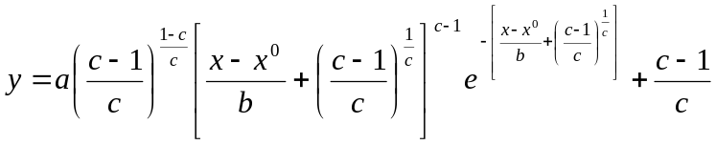
where y is a branch length, x is a node number, x⁰, a, b, and c are parameters determined with the experimental data. All parameters have the same order of magnitude for all treatment depending on plant variety, time, and temperature. Examples of this approximation are shown in Fig. 21.

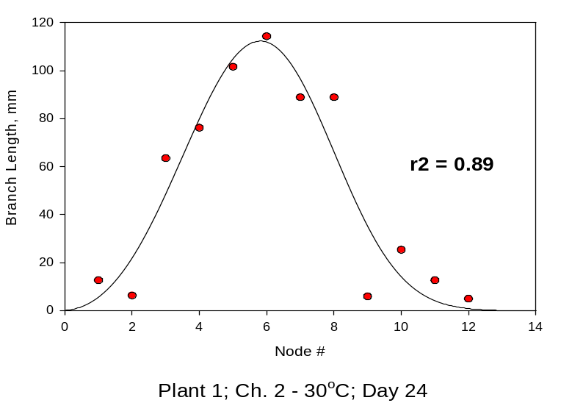
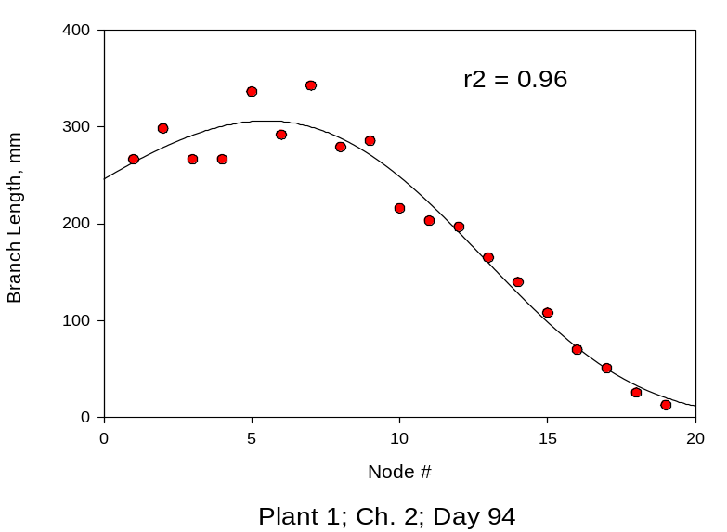

Fig 21. Dependences of the branch length on node number.
Therefore, all characteristics needed at this stage of L-systems modeling of marijuana were formalized and used in the models described in the previous section.
We also have the data on leaves sizes and there are high quality approximations of them. Partly they were described in the previous reports. At the next stages of modeling when we will simulate leaves growth more accurately, we will use them and describe accordingly.

4. Discussion and Further Developments

Measurements in this work provided necessary data to parameterize the L-system model. The program of measurements was typical for crop modeling research although the morphological measurements had to be made in more detail. The additional information on the plant architecture has been read from photographs.
Specifics of applying L-systems in crop modeling are such that most crop models simulate a "typical" or an "average" plant in a canopy. For such plant, a mechanistic crop model (i.e. GOSSYM, GLYCIM) provides information on internode elongation rates, rates of leaf appearance, growth of leaf area, branching, leaf turgor and senescence and biomass distribution between organs as dependent of environmental variables. Data collection, that is sufficient to parameterize such a model, is sufficient also to parameterize the L-system model. Linking a mechanistic crop simulator with L-system appears feasible.
The accuracy of an L-system model presents an interesting avenue for further research and a topic for discussion. One may want to assess an ability of the model to simulate the architecture of a specific single plant. A complex set of measurements has to be made, and three-dimensional digital instruments appear to be needed. Room and Hanan [4] indicate the desirability of using computer aided x-ray tomography and NMR devices. Such measurements undoubtedly would enrich knowledge about development of individual organism of plant in which “topological and geometric positions have not received the attention they deserve” [4]. In general, the studies at the level of individual plant are not given the attention they deserve, and the wider use of L-system modeling can help mend this situation. However, even at the level of a single plant the issue of accuracy depends on the question asked. For example, it is not obvious that estimating light interception by leaves of different age may require the same accuracy of the plant architecture representation as estimating temperature and gas regime and gradients. In crop modeling, where one deals with a canopy with high variability in individual plant parameters, architecture representation with L-systems may require yet different accuracy. Here the evaluation of L-system model accuracy should be what Wösten et al. [5] called “functional”. The canopy built with L-system models should react to the environmental variations similarly to real canopies. Specific criteria to compare simulated and measured canopies are yet to be developed. Nevertheless, proposed rejection of tape and ruler as difficult inaccurate and labor consuming devices for L-system modeling data collection [4] seems to be premature.
Introduction of L-systems in crop modeling would add a new facet to the problem of crop model validation. Complete validation of a model is generally impossible [6, 7], it is only possible to prove that a model is not valid. Data on of crop growth and development are always available only for a limited range of experimental conditions. Testing a model against those data usually gives some confidence in the model. However, more information about model validity is obtained from Monte Carlo-type simulations for environmental scenarios different from those observed. Usually educated guesses exist about crop behavior in various scenarios and visualization of crop growth helps to perceive model validity, provided the model does a good job, or indicates crop model weaknesses.
Virtual plants enhance several specific features of human-computer interactions of user interfaces for crop simulations. As it is pointed out in [8] presenting a user interface for on-farm crop simulations (GUICS), a successful user interface “is built on the usability paradigm developed by software designers and has a user-centered design based on results of human-computer interaction studies. The usability of the interface is facilitated with special features that enhance the directness, user-in-control, consistency, forgiveness, feedback, and simplicity of the interface”. Directness means taking into account the fact that humans are much better at recognition than at recollection [8, 9]. For a farmer, seeing directly on a computer screen a virtual plant undergoing a stress and demonstrating correct reactions to it would be direct indication that the management scenario is not the best one. At this point, there is no need for the farmer to check the tables and graphs. When a scenario is close to the optimal one, just an image is not sufficient for decision making, the quantitative information is needed. Consistency allows users to learn more quickly, and animated plant images should be of a great help. Users need to know that the software is responding to the changes he/she made (feedback features), and the virtual plant/crop provides this feature better than any table, graph, or text. GUICS and other interfaces provide simplicity features (easy to learn and easy to use) that always is a compromise between maximum functionality and maximum simplicity. These observations go in tune with Prusinkevicz's article on synergy between art, science, and information technology [10], in which he posed the question “Is it necessary to represent the results of simulations realistically for visual comparison purposes?” and answered positively. The analysis of the basics of the user interface requirements shows that the L-systems model coupled with a crop model could serve as an interactive and attractive for users component of a crop model interface.
The main use of crop models is the comparison of multiple scenarios to select management decision or the comparison of results of the same management decision for several weather scenarios. Final numbers of yields or harvest dates may be believable but remain inexplicable for the users. Visualization of crop growth should remove the mystery from the model performance and should help to build a confidence in crop models.
L-system modeling have come a long way since 1968 when L-systems presented "closed cybernetic systems incapable of simulating any form of communication between a modeled plant and its environment" [10]. Development of environmentally sensitive, parametric, open L-systems made it possible such that the results of this work allow us to conclude that the introduction of L-systems in crop modeling is a viable and potentially beneficial development.
Developing and using the marijuana crop model for detection purposes gives a new perspective to the L-systems development. Since this technology allows us to simulate the reflectance and transmittance quality of surfaces, they give us an opportunity to use the models in remote sensing studies.
Next steps in developing this study are (in order of importance for the detection purposes):
  - To further develop the open environmental model including L-system model, plant growth model, model of the environment, and the weather data in a whole system according to the scheme presented in Fig. 11.
  - To develop the models the way that it is easy to switch from the color map mode to the materials mode in order to account for optical properties of leaves and to use the models in remote sensing studies and applications.
  - To introduce an additional productions parameter that would represent time explicitly (now in marijuana models time is accounted for but implicitly via other parameters). It would not only allows us to output the state of plants at any particular moments of time but it will make simulations completely continuous.
  - To enhance the models for marijuana leaves accounting for the quantitative information about leaves colleted in our experiments and to create a possibility to easily switch from one cultivar to another. They often differ in number of leaf blades and in sizes.

References

1. http://www.cpsc.ucalgary.ca/projects/bmv/vlab/index.html
2. Mi, X., Zou, Y., and Wei, W. 2003. The model-document-view architecture and its application in visual rice Growth model. Agron. J. 95.
3. Prusinkiewicz, P. and Lindenmayer, A. 1996. The Algorithmic Beauty of Plants. Springer-Verlag, New York.
4. Room, P. M. and Hanan, J. S. (1995) Virtual cotton: a new tool for research, management and training. Proceedings of the World Cotton Research Conference-1: Challenging the Future, Brisbane, Australia, February 14-17, 1994. Editors: G.A. Constable and N.W. Forrester. Pages 40-44. CSIRO Australia.
5. Wösten, J. H. M., C. H. J. E. Schuren, J. Bouma, and A. Stein. 1990. Use of practical aspects of soil behavior to evaluate different methods to generate soil hydraulic functions. Hydrol. Processes 4: 299-310.
6. Van Horn, R.L. 1971. Validation of simulation results. Management Science 17: 247-258.

7. Pachepsky, L.B., Haskett, J.D., Acock, B. 1995. An adequate model of photosynthesis. 1. Parameterization, validation and comparison of models. Agricultural Systems 50: 209-225.
8. Acock, B., Pachepsky, Y.A., Mironenko, E. V., Whisler, F.D. Reddy V. 1999. GUICS: A generic user interface for on-farm crop simulation. Agronomy Journal 91(4): 657-665.
9. Redmond-Pyle, D., and Moore, A. 1995. Graphical user interface design and evaluation (GUIDE). Prentice Hall, Englewood Cliffs, NJ
10. Mĕch, R. and Prusinkiewicz, P. 1996. Visual models of plants interacting with their environment. Computer Graphics (SIGGRAPH '96 Proceedings), 30:397-410.

