USING IT and GIS to IMPROVE CROP ASSESSMENTS
LtCol Michael L. Thomas
National Guard Bureau Counterdrug Office
925 Dalney St STOP 0841, Atlanta, Ga, 30332,
Office (404) 894-0621, Fax (404) 894-6199
mthomas@eoeml.gtri.gatech.edu

Dr. Steve Hallman

Dept IMEB, Kettering University
1700 West Third Ave., Flint, MI 48504 USA,
Office (800) 955.4464 x9774 fax: (810) 762.9944
hallman@wwnet.net

Dr. Michel Plaisent

Dept Management and Technology
University of Quebec in Montreal
315 east Sainte-Catherine
Montreal, Canada H3C 4R2
(514) 987-3000 ext 4253, fax: (514) 987-3343,
michel.plaisent@uqam.ca
Dr. Prosper Bernard
Dept Strategy of Affairs
University of Quebec in Montreal
315 east Sainte-Catherine,
Montreal, Canada H3C 4R2,
tel: (514) 987-4250, fax: (514) 987-3343,
prosper1@compuserve.com

Abstract
Without attacking the issue of marijuana, it is practically impossible to meet the stated goals of the President’s overall plan for decreasing illicit drug use. Within this context, this paper will examine the most authoritative data published by the U.S. government agencies that specialize in counter-narcotics issues. The objective of this paper is to describe how IT and GIS can help the drug policy community by providing possible better estimates of illegal crops. Pioneering work in imagery and crop estimation was done by the US Dept of Agriculture as far back as the 1930’s. Archeologists use modern GIS techniques to develop areas of interest for historical digs. Specifically, a DSS design is presented, relying on three components: Functions necessary for the generation of a cueing layer, functions that interface with the Digital Mapping Server, and functions demanded by state agencies. The practicability of this approach has been demonstrated in a pilot project in the state of Mississippi, and is thus advocated. Deploying the Beta version of the model increased eradication efficiencies by an estimated 21% according to the lead Law Enforcement Agency using the technology in the state of Mississippi. Following this success, efforts are currently underway to deploy the technology in both the Appalachian region and the state of California – both high production areas of interest.

Keywords
Information Technology, Geographic Information Systems, GIS, DSS

Introduction

Clearly if the president’s goals for an overall decrease of drug are to occur, marijuana must not be ignored given the proportion of the problem it makes up. No exact estimates of the amount of marijuana available in the United States have been made, and there are no reliable estimates for domestic production. The widespread, clandestine cultivation and production of marijuana at indoor and outdoor sites in the United States and the lack of cannabis cultivation monitoring systems and surveys make it practically impossible to have an accurate assessment of the location and extent of cultivation and production. Drug-trafficking organizations in four countries—Mexico, Colombia, Canada, and Jamaica—supply most of the foreign-produced marijuana available in the United States. Thus, the only data that can provide limited insight into marijuana availability are eradication and seizure statistics.

The ONDCP (Office of National Drug Control Policy) recently tasked the Marijuana Availability Working Group (MAWG) with developing a methodology for making a reliable estimate of the amount of marijuana available in the United States annually. The MAWG, made up of members of various federal agencies, labeled its two-part methodology the Marijuana Availability Model (MAM). Using its MAM, the MAWG calculated a speculative estimate of domestic marijuana production by applying three hypothetical seizure rates to domestic cannabis eradication figures. In calculating the availability of domestically produced marijuana, the MAWG relied on cannabis eradication statistics along with plant yield estimates. The lack of direct information on the magnitude of the domestic production component created considerable uncertainty in the estimate. In estimating the quantity of foreign-produced marijuana, the MAWG relied on a two-step approach. First, it estimated marijuana production in Mexico on the basis of data developed by the Crime and Narcotics Center (CNC) along with seizure statistics, both foreign and domestic. Second, it estimated the availability of foreign-produced marijuana from other source countries based on a calculation of the effectiveness of U.S. Customs Service (USCS) enforcement efforts against shipments of marijuana produced in Mexico.

Possible Methods For Improving Estimates Of Marijuana
The actual exact quantity of domestically produced marijuana that was available in the United States in 2001 is unknown. While the MAWG did develop the methodology for being able to determine availability in the future years, there is a huge uncertainty in the required data, some of which do not currently exist and prevents the derivation of a credible estimate using this approach. What was more significant in the course of developing a methodology for estimating marijuana availability, the MAWG identified a number of data limitations and intelligence gaps that significantly influence the accuracy and reliability of the current estimates. They made nine specific recommendations as to how best to address the limitations of the data concerning both domestic and foreign produced cannabis. The MAWG recommended developing and supporting a program to derive statistically valid estimates of cannabis cultivation on U.S. public lands. One of the programs cited as a model included the efforts of the National Guard Bureau’s Counterdrug Office (NGB CD) development of remote technical means of spotting high probability grow areas and predicting the level of cultivation, one of which is the Mississippi Counter-Drug Enforcement Decision Support System (MCEDSS).
A cornerstone technology for NGB-CD, which was developed under the CD-GRASS program, MCEDSS, is designed to predict marijuana cultivation sites for eradication as well as providing support for mission planning and assessment. To date, MCEDSS has been successfully deployed within the State of Mississippi and is in operational use by the Mississippi National Guard and the Mississippi Bureau of Narcotics. It is the intent of NGB-CD for this overall Decision Support System (DSS) for marijuana prediction and eradication support to be deployed to as many States and Regions that are relevant for marijuana eradication missions. In fact, since for FY03 marijuana has been highlighted in the overall National Drug Control Strategy as the number one drug targeted for reduction, the reduction of marijuana production would have the single largest impact on the overall drug program in the US. NGB-CD wants to see MCEDSS deployed in other high marijuana probability areas – the Appalachian HIDTA (High Intensity Drug Trafficking Area) for example. This HIDTA is one of the only single-drug HIDTAs and the “single-drug” in Appalachia is marijuana. The new national system will simply be termed the Decision Support System (DSS). The focus of this work is to further deploy this marijuana prediction DSS into other States and Regions with the initial focus on the Appalachian HIDTA region (which includes 65 counties across TN, WV, and KY). As a first step to national implementation of the DSS, a workshop was held on April 29, 2003, at the John C. Stennis Space Center to obtain input from counterdrug personnel in the Appalachian region. The working groups addressed the question list but also engaged in a great deal of general discussion. Several critical issues quickly became apparent:
- There is a great deal of variability from one state to another in:
  - Search planning
  - Field operations
  - Reporting
  - Existing infrastructure
- Training is possibly the most important issue to the states, and manpower shortages preclude sending personnel away for training
- There is little knowledge of geographic information systems (GIS), but there is a general familiarity with maps (especially with National Guard personnel)
- Many personnel cannot are not fully computer literate, nor are they familiar with global positioning systems (GPS)
- States do not have the resources to maintain hardware/software systems
- There are pockets of interest in every organization, but leadership must come from above

Marijuana Site Report
The Stennis working group developed a “Marijuana Site Report.” The main reason for this is the appraent lack of consistent reporting between and among state and local agencies up to the federal level. The consensus was that there should be a very short required portion giving little more that the site location and number of plants. An optional section that contained the information required by the DEA in their Monthly Statistical Report should follow this required section. The reason for separating the two portions of the report is that some states already have a reporting system for the information required by the DEA Monthly Statistical Report and having a Site Report with the same information could be a duplication of effort (i.e. added paperwork). Additional site characteristics that would be of value for profiling purposes were viewed as extra paperwork and were not viewed favorably. A consensus DRAFT Site Report is provided in Table 1.
REQUIRED FIELDS
Agent ID e.g. badge number or last name
Date xx/xx/xx
Type of Site cultivated or ditchweed (If ditchweed related cost)
Eradicated yes or no
Number of plants number, Latitude Longitude
OPTIONAL FIELDS
Arrests
State charges yes or no
Federal charges yes or no
Value of Asset Seizures
Cash dollars
Real estate dollars
Other dollars
Weapon Seizures
Firearms number
Other number
Herbicide Eradication
Number of plants eradicated number
State Funded Herbicide Eradication
Number of plants eradicated number
Site Maintenance poor, moderate or good
Booby Traps yes or no
Method of Planting containers or in ground
Table 1 Draft Marijuana Site Report.
The Site Report concept provides freeware to run on a desktop or laptop computer that consists of a user-friendly report template. A paper version also is provided. Marijuana site information is recorded directly on a computer or on paper in the field. If on a computer, the file is saved as a delimited file. Either type of report can then be sent on a periodic basis to a central collecting organization at the Federal level. When recorded on a computer, the files are simply be emailed to the Federal collecting organization. When recorded on paper, the reports are mailed or Faxed to the Federal collecting organization, which enters the records into a computer using the freeware template. Once all reports have been collected on a single computer, the files are imported into a Microsoft Excel spreadsheet or database. The compilation of field reports for the Monthly Statistical Report has been easily automated (e.g. simply totaling the numbers in each column of a spreadsheet). Once reports are collected, a single computer produces a shape file. A shape file is a format that allows the data to be plotted and overlaid with and on other data. The shape file format also allows a user to place the computer cursor on a given plot location and click to view the associated Site Report.
The Agent ID combined with Date and an automatically entered (by the computer) time, combine to provide a specific identification for each record. The time is not important, but it makes the identification unique. Site Type requires selecting either cultivated site or ditchweed. Eradicated requires selecting either yes or no. This selection is required because some states (e.g. California) do not always have sufficient manpower to eradicate, or it is a legal medicinal plot. The former situation may be further aggravated by the DoD decision to stop National Guard support for “whacking and stacking.” Characteristics consist of latitude, longitude, and number of plants. The entry of latitude and longitude will allow a selection of format. They can be entered as either: degrees and decimal degrees; degrees, minutes, and decimal minutes; or degrees, minutes, seconds, and decimal seconds. For the locations to be of value there is a minimal accuracy of latitude and longitude that must be recorded. These are; seconds of arc to one decimal place (e.g. 30° 10' 4.3"), minutes of arc to three decimal places (e.g. 30° 10.072'), or degrees of arc to five decimal places (e.g. 30.16786°). Number of plants is simply the number. All REQUIRED FIELDS must be completed before the record can be saved.
At the bottom of the REQUIRED FIELDS template would be a button labeled OPTIONAL FIELDS. Clicking on the button would open an additional template. It would be up to each state as to whether or not they would instruct agents to complete these optional fields. The optional fields include the remainder of the data required on the DEA Monthly Statistical Report, plus three additional fields suggested at the workshop (Site Maintenance, Booby Traps, and Method of Planting). The entry for Site Maintenance requires a selection of poor, moderate, or good. These are intended to be a judgment of how much effort the grower has put into the sight, i.e. is surveillance warranted. Scattered plants with no apparent maintenance would rate a poor, while evidence of fertilizer, watering, and weeding would rate a good. Booby Traps would require a yes or no selection. Method of Planting would require a selection of containers or in ground.

DSS Conceptual Design
The DSS basic concept is to acquire historical marijuana location data from each state, to perform analysis on these data, to develop and make available a Marijuana Site Report, and to provide instructions for how to implement the Moving Map function. The Digital Mapping Server (DMS) serves a wide variety of digital maps and free downloadable viewing software (freeware). The states then combine these functions to provide the DSS capabilities. It should be noted some fields such as Internet Weather and State-Wide Telephone Book functions of the MCEDSS are not included in Table 1. This is because there was no significant interest in these functions expressed by workshop attendees.
Possibly the most significant factor confirmed by the workshop was that there is tremendous variability from one state CD LEA organization to another. This applies to their operations, infrastructure, and personnel training. Many counterdrug personnel are not computer literate and many state offices do not even have desktop computers. It appears that in some states a likely scenario will be to use a full electronic version of the DSS only during the annual search planning session, with field reporting being on paper forms sent to a central location for collection and digital entry. This poses the question as to who will be the central repository of historical data in each state.
There appears to be a general acceptance of the predictive cueing layer concept developed and utilized for MCEDSS, since many attendees indicated that they were already using various types of profiling. However, there also appeared to be some confusion about the cueing layer. It is based solely on the spatial characteristics of marijuana plots and not a profile of the growers (i.e. it is area-based, not individual-based). The rules used to develop the cueing layer are made available, since they can also be of assistance to observers in the field (e.g. proximity to roads or topographic characteristics). It needs to be pointed out that unemployment rates should also be investigated as a potential rule.
There is consensus among the attendees that the Marijuana Site Report is of value in reducing errors in the data and facilitates the compilation of DEA’s Monthly Statistical Report. It’s been seen that including too much information on the report is viewed as increased paperwork. Acceptance of the reports is based upon making agents’ jobs easier.
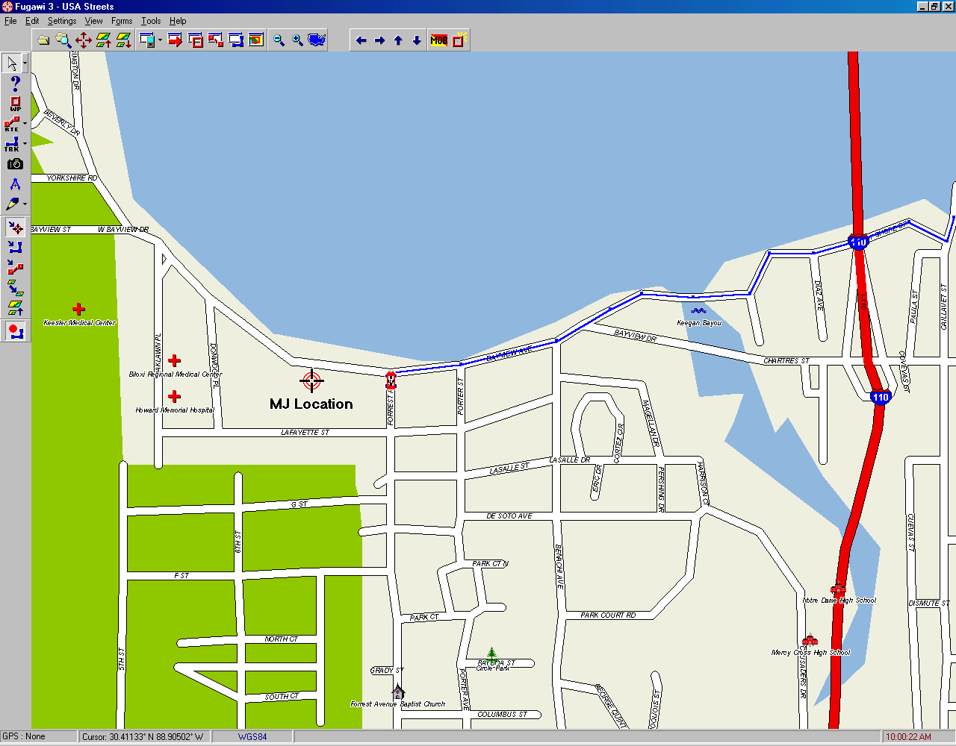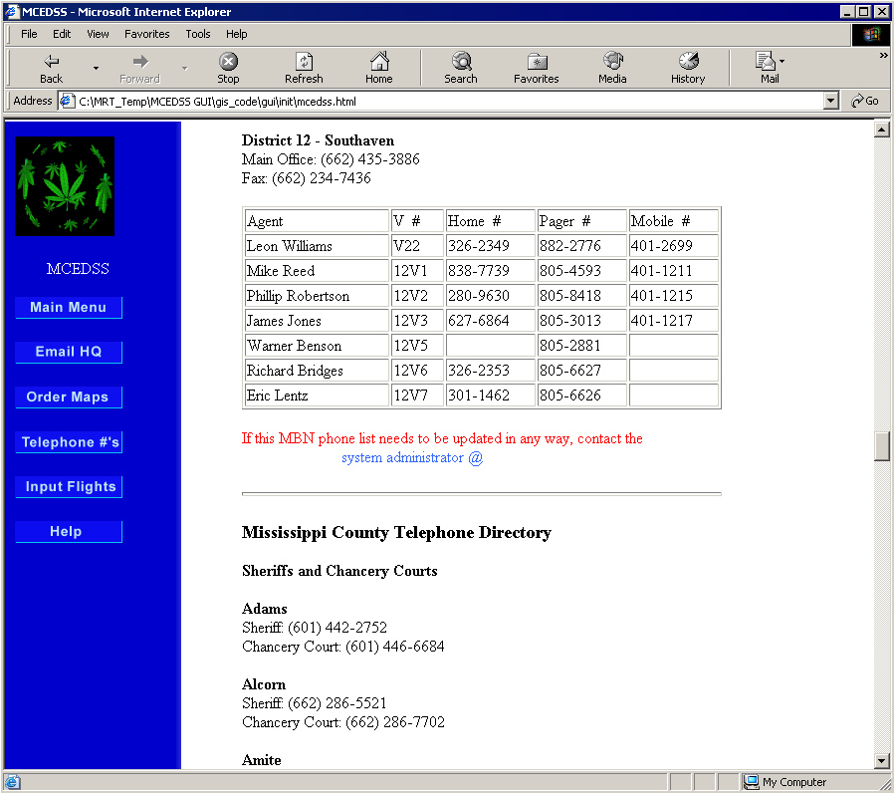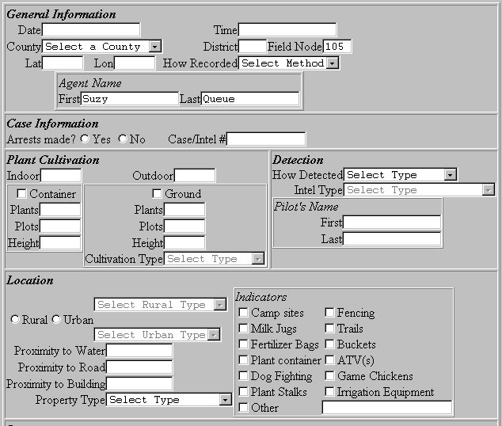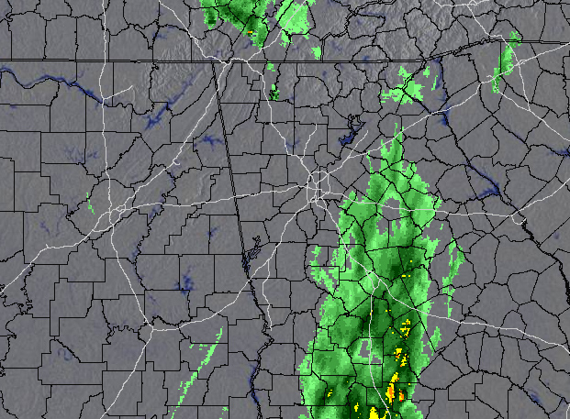
Figure 2 Moving Map Display

Figure 4 State-wide telephone directory
Figure 1 MCEDSS Eradication Report
Figure 3 Internet weather
The MAWG also recommended instituting foreign cultivation surveys in the three countries other than Mexico that constitute the primary source areas for foreign-produced marijuana in the United States – specifically Canada, Colombia, and Jamaica. This would provide a mechanism for determining overall potential marijuana production affecting the United States and thereby provide a more direct estimate of foreign marijuana availability than currently possible with MAM. A variation of predictive approach is currently being tested in Afghanistan for estimating poppy cultivation using LandSat GIS data. Practically all of the data contained in this paper are derived from the online publications of these agencies. Such publications provide the most up-to-date information available on the subject. Unfortunately, the estimates of exactly how much cannabis is actually available is open to interpretation.
OVERVIEW OF NEURAL NETWORK-ASSISTED PREDICTIVE MODELING
Process Summary
NGB CDX has developed an inductive modeling process that creates a predictive spatial profile for features of interest. One application of this technology is a predictive map showing the likely areas within a state for the outdoor cultivation of marijuana.
The predictions are made on the basis that historical cultivation plots are located in patterns that can be identified using a neural net classification algorithm. The environmental factors that match those patterns can be mapped out, showing areas where marijuana is most likely to be cultivated relative to other regions in the study area (e.g. a state or National Forest). The map layer that shows the predicted areas is termed the cueing layer, because it cues pilots and observers where to begin their searches.
The general process flow illustrated in Figure 5 can be summarized as follows. GIS layers are standardized to facilitate analysis, including a Principal Components Analysis (PCA) of some of the more highly correlated GIS layers (i.e. redundant information across several layers). Next, the standardized GIS layers, including principal components layers, and historical plot locations are used to train the neural net. Once trained, the neural net can take the input layers and map out the relative likelihood that any given location in the study area matches the site conditions for growing. The steps used to build the model are discussed in more detail below.

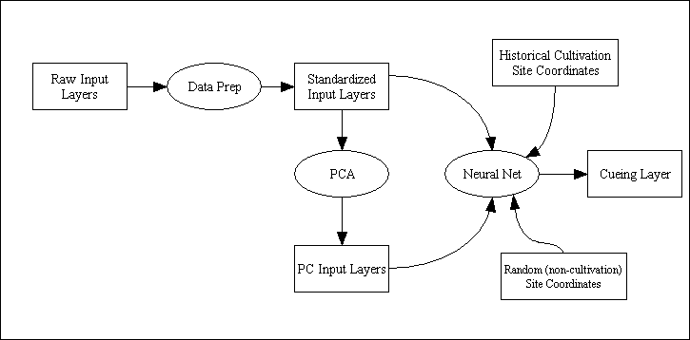
Figure 5. General illustration of the cueing layer creation process.

Predictive Modeling Process in Detail
The process consists of seven steps: (1) acquiring all applicable spatial data in geographic information system (GIS) format, (2) acquiring the latitude and longitude of historical outdoor marijuana grow sites, (3) generating sets of random locations, (4) performing a principal components analysis, (5) training a neural network, (6) using the neural network to produce the cueing layer, and (7) using the GIS software to produce a map of the cueing layer.
Step 1: All applicable GIS data for the state to be processed is collected. These data consist of the 36 demographic parameters in the U.S. Census Summary File, 30 parameters calculated from the National Elevation Dataset (e.g., elevation, slope, and a number of roughness parameters), and the commonly available GIS coverages (e.g., political boundaries, federal land, roads, streams, soil type, vegetative cover).
Step 2: The latitude and longitude of historical outdoor cultivation sites in the state of interest are acquired. These data are sometimes maintained by the National Guard and sometimes by the lead civilian counterdrug agency, but it should be noted that not all states maintain these data. Twenty percent of these data points are randomly selected and withheld from the analysis to be used later for estimating the predictive ability of the cueing layer.
Step 3: A set of random locations (latitude and longitude) equal in number to the historical cultivation location set are generated.
Step 4: A principal components analysis is performed on the GIS data to reduce the number of data layers.
Step 5: A neural network analysis of the principal components, GIS data that were not processed with PCA, and point locations (both plots and random) is performed to identify patterns in the data (i.e., what characteristics differentiate the plot locations from the random locations).
Step 6: The neural network uses the patterns it previously identified to create a predictive map layer showing the likelihood for marijuana cultivation relative to random chance. This essentially assigns each pixel in the cueing layer a value indicating the similarity of the conditions (e.g. environment, demographics, etc) at the pixel to known conditions at previously found grow sites.
Step 7: A GIS combines the predictive map layer with additional GIS layers (e.g., county boundaries, roads, topography) to make a statewide map using a continuous color scale (blue to red) with hot colors representing areas more likely than random and cold colors indicating areas less likely than random.
Interpreting the Cueing Layer
Simply stated, the cueing layer describes the relative likelihood of an area represented by a pixel on the map being similar to the characteristics of actual marijuana plots. The values in the cueing layer illustrate the relative likelihood along a continuum, ranging from least likely to most likely. It should be noted that this is not to be confused with a measure of statistical probability. The cueing layer is based on the probability that any given pixel matches the characteristics of the average historical cultivation plot characteristics. This is different from stating the probability that any given pixel will contain a cultivation plot, because conditions can be perfect for marijuana and yet not contain a plot. Conversely, a site with poor conditions (e.g. an urban backyard in an arid region) may actually have a cultivation plot.
There are several ways of displaying the predicted likelihood as determined by the neural network. The full range of values, from least likely to most likely, can be shown along a color gradient (see Figure 6). Alternatively, the range of values can be grouped into classes, the most simple classification being areas ‘less likely than random’, ‘as likely as random’, or ‘more likely than random’ (see Figure 7).
The factors in California that were correlated with outdoor-grown marijuana were primarily driven by rainfall and area human population demographics (e.g. population density). The prediction was made using all cultivation data available for the state to provide the neural network with a representative statistical sample for training the prediction algorithm. Even though the areas of specific interest of NDIC are limited to federal land, using statewide data to make the prediction ensured that the most accurate prediction possible was made for federal lands.
If only the predictions for federal lands are of interest, the cueing layer values must be rescaled to properly encompass the range of likelihood found in those areas. This is especially important because proximity to federal lands was a predictive factor in the analysis (i.e. marijuana cultivation locations are partially correlated with federal land). Rescaling the data for the federal lands essentially improves the contrast of the colors in those areas. Figure 4 shows the cueing layer predictions after they have been rescaled for federal land.
Summary
NGB CDX has taken techniques used in natural resource management, archaeology, crime mapping, and other disciplines, and combined them to provide law enforcement with the unique capability of characterizing a complex set of relationships with a simple map. These techniques also provide insight into the factors present in determining the distribution of outdoor-grown marijuana across the landscape. It is currently being statistically validated in the National Forests of California, (Figs 6-8)
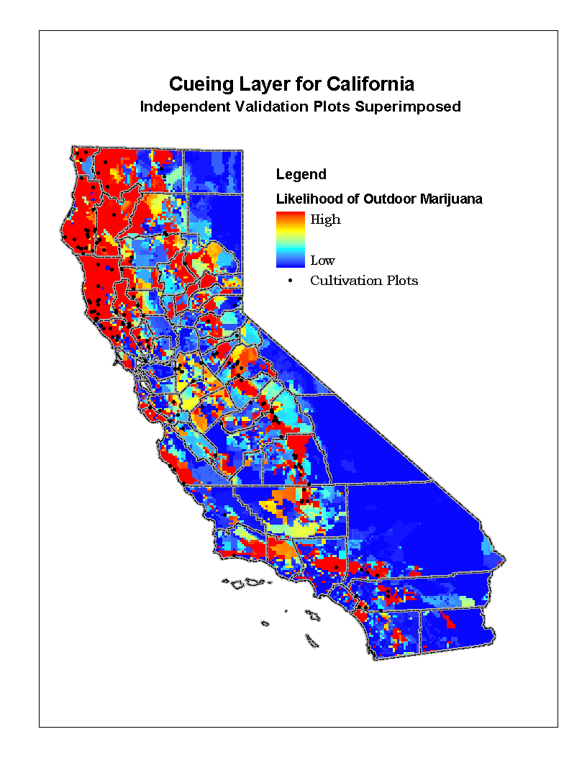
Figure 6. Cueing Layer displayed using a continuous color scale. Hot colors indicate likely areas for finding marijuana, and cold colors indicate relatively unlikely areas.
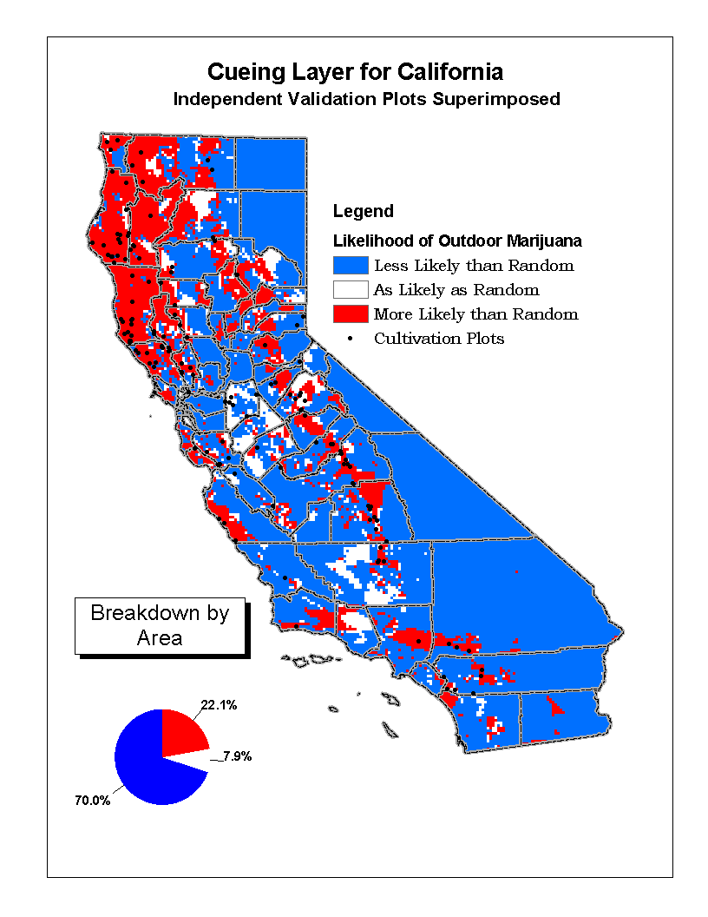
Figure 7. Cueing Layer displayed using a 3-class scheme. Red indicates likely areas for finding marijuana, and blue indicates relatively unlikely areas. Areas where you have the same chance as throwing darts at the map are white.
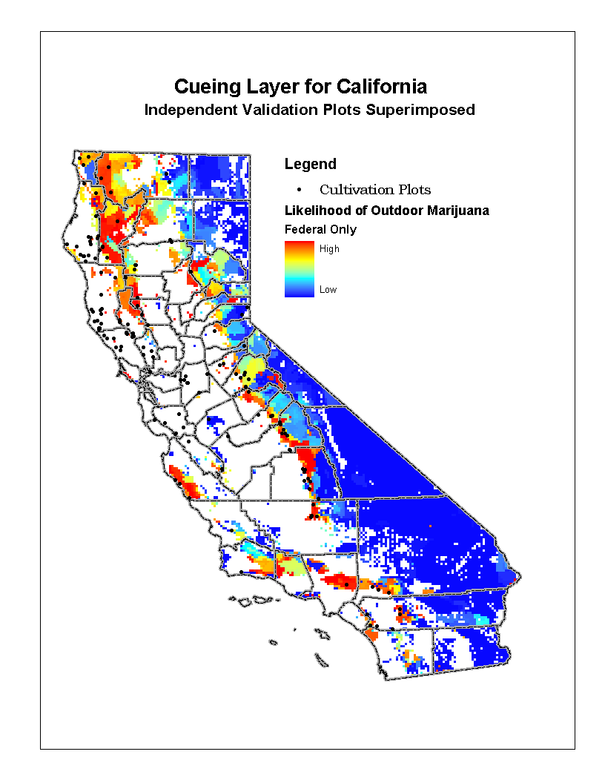
Figure 8. Cueing Layer for only the federal lands in California. The cueing layer values have been rescaled for those pixels representing federal lands. Note that this accentuates the detail in those areas more than the statewide cueing layer (Figure 6).

References
Canada. Criminal Intelligence Service Canada (CISC) (2003). Asian-Based Organized Crime, Annual Report on Organized Crime in Canada. http://www.cisc.gc.ca/AnnualReport2003/Document/CISC%202003%20Annual%20Report.pdf

Reuter, Peter, (1996). The Mismeasurement of Illegal Drug Markets: The Implications of Its Irrelevance. http://www.puaf.umd.edu/faculty/papers/reuter/pozo.pdf, Pozo, Susan, ed.(1996). Exploring the Underground Economy: Studies of Illegal and Unreported Activity. Kalamazoo, Michigan: W.E. Upjohn Institute for Employment Research, 1996. 172 p.

United Nations Office on Drugs and Crime (UNODC), (2003). Cannabis, Chapter 1.1.4, Global Illicit Drug Trends. Vienna, Austria.

United Nations Office on Drugs and Crime (UNODC), (2003) . “Trafficking in Cannabis,” Chapter 1.2.4, Global Illicit Drug Trends, 2003. Vienna, Austria. http://www.unodc.org/pdf/report_2003-06-26_1.pdf

U.S. Congress. House of Representatives. Statement of Frank Deckert, Superintendent, Big Bend National Park Service, Department of the Interior, Before the House Government Reform Subcommittee on Criminal Justice, Drug Policy, and Human Resources, Regarding the Impact of the Drug Trade on Border Security and National Parks, April 15, 2003. http://www.nps.gov/legal/testimony/108th/lebigben.htm

U.S. Department of Justice (2001). Bureau of Justice Statistics. Sourcebook of Criminal Justice Statistics 2000, Table 4.38, December 2001.

U.S. Department of Justice. Drug Enforcement Administration. DEA Public Affairs (2003). Drug Trafficking in the United States, July 25, 2003. http://www.usdoj.gov/dea/concern/drug_trafficking.html

U.S. Department of Justice. Drug Enforcement Administration (1999). Drug Intelligence Brief: The Cannabis Situation in the United States, December 1999. http://www.usdoj.gov/dea/pubs/intel/99028/99028.html

U.S. Department of Justice. National Drug Intelligence Center, (2003). National Drug Threat Assessment 2003 (Product No. 2003-Q0317-001). http://www.usdoj.gov/ndic/pubs3/3300/marijuan.htm#Top

U.S. Substance Abuse and Mental Health Services Administration, (2003). Overview of Findings from the 2002 National Survey on Drug Use and Health (Office of Applied Studies, NHSDA Series H-21, DHHS Publication No. SMA 03–3774). http://www.samhsa.gov/oas/nhsda/2k2nsduh/Overview/2k2Overview.htm#toc

White House. Executive Office of the President. Office of National Drug Control Policy, (2003). Drug Facts: Marijuana. http://www.whitehousedrugpolicy.gov/drugfact/marijuana/index.html

